Your details
Title
Name
Address

Post code
Telephone
E-mail
Data protection: All personal data will be stored manually and by computer solely to maintain the records for this project. No personal details will be passed on to third parties for any other purpose.
GIFT AID
Please tick if you are a UK Taxpayer and are happy for us to claim Gift Aid on this donation. (Thus, for every £1 you give, we will receive an additional 25p from HMRC)
Signature
Date
Payment amount £ paid by:

Cheque, payable to Harrold Centre Management Committee

Direct bank transfer to NatWest Bank
Sort Code 60-02-13
Account No. 08089183
Account Name Harrold Centre
Management Committee
Please use “Brick“+your initial & surname as a ref
Your Inscription
A standard, single depth brick, with black engraving will be £40 and can have two lines of text (maximum of 16 characters, including punctuation & spaces, per line).
A deluxe, double depth brick, with gold or black engraving will be £80 and can have up to four lines of text (maximum of 16 characters, including punctuation & spaces, per line).
Note there are now three special characters that can also be used; they are:-
and they cost an additional £7 per character.
Please use BLOCK CAPITALS and leave a space between each word.
1
2
Additionally use lines 3 & 4 if you are buying an £80 brick
3
4
If ordering a double, £80 brick, please specify whether Gold or Black text is preferred
Please return the completed form, along with payment if appropriate to:-
Sue Chaplin. 2 High Street
Harrold, Bedford, MK43 7DQ
If you have any queries please contact Sue via email at sljchaplin@aol.com or on 926405
Additional leaflets are also available at Harrold Post Office

Harrold Centre
Redevelopment

Please Buy a Brick
... to help fund further exciting improvements to the Harrold Centre - and make it fit for the 21st century and beyond
... and to contribute towards creating an attractive & welcoming venue with greatly improved, up-to-date facilities
... and to be remembered on our sponsorship wall

The Harrold Centre

Recently refurbished and extended, The Harold Centre is now a thriving and active resource becoming increasingly popular with both regular and occasional users. It is an ideal venue for a wide range of activities making use of its many modern facilities including:-
- A well equipped, spacious modern kitchen
- A large hall with seating for 100
- A separate fully licensed bar area
- Meeting rooms
- A brand new sound and PA system
- Film & computer projection facilities
- 3 powered and DMX-cabled lighting bars with 18 channels feeding 3 dimmer racks
- Disabled access and toilet facilities

Further fundraising is needed to continue with these improvements

You can help by donating £40 or £80 in return for an engraved brick with your personal message. This will be added to the feature wall of sponsors’ bricks displayed in the attractive, light-filled atrium. If you haven’t yet done so, pop in and have a look when the Centre is open - check the diary at:-

http://harroldcentre.co.uk/calendar/

Bricks come in two sizes:
Single 210mm x 105 (standard brick size) and will be engraved in black, e.g.

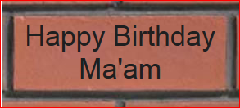

Double 210 x 210 (double depth) and can be engraved in gold or black:

Congratulations
Romeo & Juliet
on your
Golden Wedding

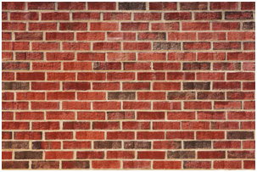
Thanks for your support

