Your details
Title
Name
Address

Post code
Telephone
E-mail
Data protection: All personal data will be stored manually and by computer solely to maintain the records for this project. No personal details will be passed on to third parties for any other purpose.
GIFT AID
Please tick if you are a UK Taxpayer and are happy for us to claim Gift Aid on this donation. (Thus, for every £1 you give, we will receive an additional 25p from HMRC)
Signature
Date
Payment amount £ paid by:
Cash, paid to
(Receipt provided)
Cheque, payable to Harrold Centre Management Committee
Direct bank transfer to NatWest Bank
Sort Code 60-02-13
Account No. 08089183
Account Name Harrold Centre
Management Committee
Please use “Brick“+your initial & surname as a ref
Your Inscription
A standard, single depth brick, with black engraving will be £40 and can have two lines of text (maximum of 16 characters, including punctuation & spaces, per line).
A deluxe, double depth brick, with gold engraving will be £80 and can have up to four lines of text (maximum of 16 characters, including punctuation & spaces, per line).

Please use BLOCK CAPITALS and leave a space between each word.
1
2
Only use lines 3 & 4 if you are buying a deluxe brick
3
4

Please return the completed form, along with payment if appropriate to:-
Sue Chaplin
13 High Street
Harrold
Bedford
MK43 7DQ
If you have any queries please contact Sue via email at sljchaplin@aol.com
Additional leaflets are also available at Harrold Post Office

Harrold Centre
Redevelopment

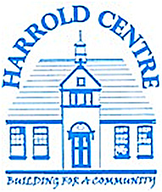

Please Buy a Brick
... to help fund essential and exciting improvements to the Harrold Centre - and make it fit for the 21st century and beyond
... and to contribute towards creating an attractive & welcoming venue with greatly improved, up-to-date facilities
... and to be remembered on our sponsorship wall

Development details

The fabric and facilities of The Harrold Centre are in serious need of refurbishment.
To finance the redevelopment a substantial sum of £275,000 has been raised so far and the Centre Committee is delighted to confirm that work will begin shortly.
The work involves a small extension at the rear of the existing building together with a total redesign and refurbishment of the interior. This will result in new toilets, including a separate disabled toilet, new kitchen & bar area, a spacious entrance lobby, additional meeting facilities and better use of existing space.
A further £55,000 is needed to fully complete this transformation. You can help enormously by donating £40 or £80 in return for which you will “own” a brick engraved with your own personal message / name.
Our intention is to build a wall of sponsors’ bricks under the new bar, or some other prime location, where they will remain as a permanent legacy.

For more details of the bricks - see opposite.

So the bar may look a bit like this:
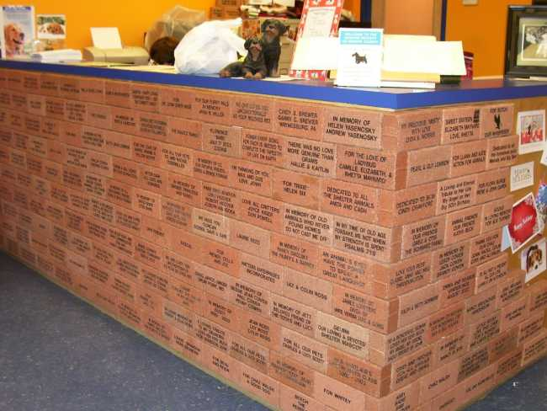

Bricks come in two sizes:
Single 210mm x 105 (standard brick size) and will be engraved in black, e.g.

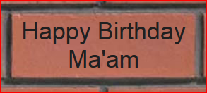

Double 210 x 210 (double depth) but will be engraved in gold:

Congratulations
Romeo & Juliet
on your
Golden Wedding

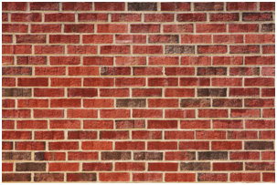
Thanks for your support

